**Experiment No :** 20

**Experiment name :** write a C program to multiply two number using plus operator

**Methodology :**

This program takes two numbers as input and uses a while loop to repeatedly add the value of the first number (num1) to the result variable num2 times. If num2 is negative, it makes it positive before entering the loop to handle negative numbers properly.

Keep in mind that this method is not efficient for large numbers, and it is primarily intended for educational purposes to demonstrate the concept of multiplication using repeated addition. For real-world applications and larger numbers, more efficient multiplication algorithms should be used..

**Flow-Chart :**

int a , b , mul , loop ;

scanf("%d %d", &a , &b);

**Code :**

printf("Multiplication of %d and %d is : %d\n", a , b , mul);

for(loop = 1 ; loop <= b ; loop++){

mul +=a ;

}

mul = 0 ;

#include<stdio.h>

int main()

{

int a , b , mul , loop ;

printf("Enter first and second number : ");

scanf("%d %d", &a , &b);

mul = 0 ;

for(loop = 1 ; loop <= b ; loop++){

mul +=a ;

}

printf("Multiplication of %d and %d is : %d\n", a , b , mul);

return 0 ;

}

**Output:**

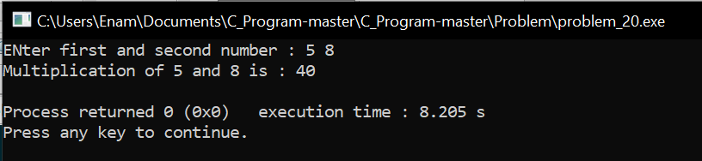

**Result discussion :**

With this program we take two numbers and multiply them using the plus operator of the two numbers and inspect the result.